
Development Request
Aria Systems
Amendments to Custom Style Critical Path programs related to the following original CP’s

200249
200376
200413
200471

Program Add-in Template Description

Program Add-in Template

Program Add-in Header
Product: | Aria27
Module: | PO
Customer name: | Dare to Bare
Installed Modules: | AL, AP, AR, GL, IC, MA, MF, PO, RM, SO, SR
Parameters setting:

.

Details Section
Add-in Name :
Add-in Objective :

Existing Initial situation: Although these amendments are requested by Dare to Bare they will be standard for these programs. Therefore a separate set of custom programs does not have to be created for Dare to Bare

Description ( Processing ) :
The Amendments to be made to these CP’s are as follows:-

1. Disable the automatic display of the User Task list at log on to Aria and anywhere else this task list appears automatically during processing

2. When the Style Critical path is created for a Style and Sales Order/Purchase order, any critical path operation where CTYCRPLN.LAUTRECALC = .F. currently shows the DREQUIRED date as blank. If the LAUTRECALC = .F. then the system date when the style critical path was created should be assumed as the required date.

3. Operations can be linked to transactions e.g. Material PO create, Material PO receipt, Style PO Create, Style PO receipt. The original request for the link to Style PO Receipt was as follows:-
When receiving in styles against a Style Purchase Order – if the status of the Style Purchase Order changes to complete – then if there is a CUTPICK record linking the Style Purchase Order to a Sales Order and that Sales Order has a Style Critical Path attached and one of the operations is linked to “ Style Purchase Order” received – then the Approval Date of that operation should be updated with the PO Receipt Date

This should be changed as follows:-

When receiving styles against a Purchase order –and on saving the receipt, if the receipt was updated to warehouse <> “PROD” i.e. POSLN.CWARECODE <> “PROD” - then if there is a CUTPICK record linking the Style Purchase order to a sales order and that sales order has a Style Critical Path attached and one or more of the operations is linked to ‘Style Purchase order receipt’ – then the Approved date of that operation should be updated with the PO receipt date. This should not significantly slow down the procedure of saving style PO receipts. If there is already an approved date for the operation linked to this transaction then do not overwrite i.e. Only update if STYCRPLN.DAPPROVED is blank

Add another item to the list of transactions which can be linked to the style critical path, titled ‘Production Samples Received’. Operations linked to this transaction should have the approved date updated based on the following:-
When receiving in styles against a Purchase order –and on saving the receipt, if receipt is updated to warehouse “PROD”, i.e. POSLN.CWARECODE = “PROD” and if there is a CUTPICK record linking the Style Purchase order to a sales order and that sales order has a Style Critical Path attached and one of the operations is linked to ‘Production Samples Received’ – then the Approved date of that operation should be updated with the PO receipt date. This should not significantly slow down the procedure of saving style PO receipts. If there is already an approved date for the operation linked to this transaction then do not overwrite i.e. Only update if STYCRPLN.DAPPROVED is blank

4. Amend the Unapproved Operations’ screen as follows:-

The heading on the selection grid for the screen should be changed from ‘View Unapproved operation by user’ to View Unapproved operations’

The title of the current option ‘Show Operations’ should be changed to ‘Show Required dates’

An additional option should be added to the grid titled:-

View operations by: with the options User or Operation

If the user selects to view by user, this will then default the list as now to the operations related to the current logged in user.

If the user selects View by operation, then a further grid option will be available titled
‘Operation’ with an In List option. As the operations are not coded and are just free text description, the users have been advised to ensure that the descriptions are consistent across all critical path templates. The In list window should list all descriptions but should not duplicate where the descriptions are the same. The user can then select using Move, Move all etc.
The screen will then list the operations selected by operation in required date order based on the selection made in ‘Show Require dates’

The selection grid for the screen would then look as follows:-

Show required dates: All
Within Default prompt dates
Within user defined prompt days

View By User
Operation

Operation In List (only available if View by ‘Operation’ selected
Above)

When the operations are listed on the screen, the user clicks on the edit icon to approve the operations and add any comments. Currently the user approves the operation by keying a date in the Approved field. This should be changed to add a check box titled ‘Appr’. When the user clicks on the check box, the Approved date is automatically updated as the current system date. Access to edit the Approved date should be disabled and it should be displayed only. Prior to saving, the user can check/uncheck the Appr box as required which will then remove/add the approved date accordingly. On saving, the operation will then be updated as approved. The user id of the user who approved the operation should be updated to STYCRPLN in a new field titled USR_APR

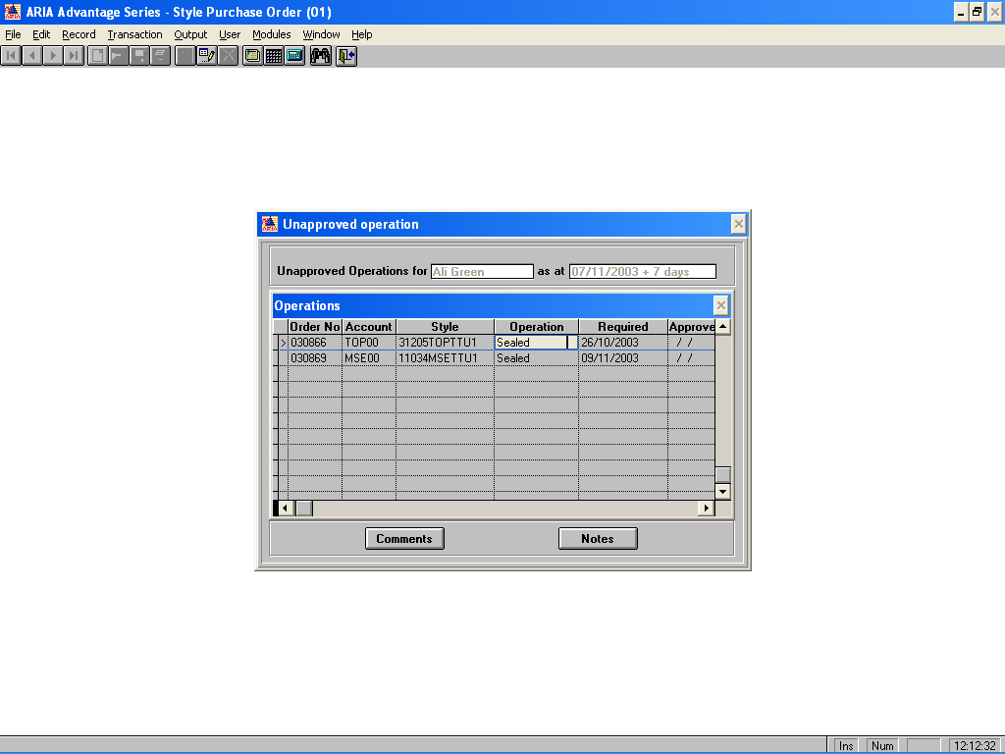

To have as many columns as possible visible on the Unapproved Operations screen without having to scroll across, the Operation description column should be reduced to display only the first 25 characters of the operation description. The Appr check box should then be inserted between the Required date and the Approved date as the Approved date does not need to be accessed by the user

